G. L. Bajaj Institute of Technology & Management Greater Noida

Department of Computer Science & Engineering (DS)
SESSION: 2026-27
Web Designing Lab (BCS-353)
Submitted To: Submitted By: Samrat Barar
Md Ishfaque Ahmed Name & Section: CSDS 2E2
Department of CSE (DS) AKTU Roll No.: 2501921540325
Greater Noida
Sr.  No. | Experiments | Date of  Experiment | Submission Date | Sign
1. | Design the following static web pages required for an online book store web site.  HOME PAGE: The static home page must contain three frames. | 03/08/2026 | 12/08/2026
2. | LOGINPAGE: All the login deatils
3. | CATOLOGUE PAGE: The catalogue page should contain the details of all the books available in the website in a table. The details should contain the following:  - Snap shot of Cover Page.  - Author Name.  - Publisher.  - Price.  - Add to cart button.
4. | CARTPAGE: The cart page contains the details about the books which are added to the cart.
5. | REGISTRATION PAGE : Create a“  registration form“ with the following fields  1)Name (Text field)  2)Password (password field)  - E-mailid(text field)  - Phone Number(text field)  - Sex(radio button)  - Date of birth(3 select boxes)  - Languages known(checkboxes–English,  Telugu, Hindi, Tamil)  - Address(text area)
6. | Js VALIDATION: Write JavaScript to validate the following fields of the above registration page.  - Name (Name should contains alphabets and the length should not be less than 6 characters).  - Password (Password should not be less than 6 characters length).
7. | Js VALIDATION:  - E-mailid (should not contain any  invalid and must follow the standard pattern(name@domain.com)  - Phone Number(Phone number should contain 10 digits only).
8. | CSS: Design a web page using CSS(Cascading Style Sheets) which includes the following:  - Use different font, styles:  In the style definition you define how each selector should work(font, color etc.). Then, in the body of your pages, you refer to these selectors to activate the styles.  - Set a background image for both the page and single elements on the page.
Greater Noida
9. | CSS:  - Control the repetition of the image with the background-repeat property.  - Define styles for links as  A:link  A:visited  A:active  A:hover
10. | Consider a small topic of your choice on which you can develop static Webpages and try to implement all topics of html, CSS and Js within the topic. Choose any one topic.  - Your Own Portfolio  - To-Do List  - Survey Form  - A Tribute Page  A Questionnaire

Greater Noida

Experiment 1
Aim : Design the following static web pages required for online book store.
Description –
// Here describe all the important points and tags that used
The project is a multi-page website titled "Online Book Store," created for G.L. Bajaj Institute of Technology and Management. It consists of a homepage (main.html), a navigation-based catalogue system, and four separate branch-wise book listing pages (cse.html, ece.html, eee.html, mech.html), each displaying book details like name, author, and price.
<html>, <head>, and <title> Tags
These form the basic skeleton of every page. The <head> section holds the page title (e.g., "Online Book Store"), which appears on the browser tab, along with any linked stylesheets. The <html> tag wraps the entire document, ensuring the browser correctly interprets it as a web page.
<header> / Banner Section
At the top of the main page, a header section displays the institute logo, the college name "G.L Bajaj Institute of Technology and Management," and the site title "Online Book Store." This is typically built using a <div> or <header> tag combined with an <img> tag for the logo.
<nav> and <a> (Anchor) Tags
A navigation bar with links — HOME, LOGIN, REGISTER, and CATALOGUE — sits below the header. These are created using <a href=""> tags, usually wrapped inside a <nav> or <ul><li> structure, allowing users to move between different pages of the site.
<ul> and <li> Tags (Sidebar Menu)
On the left sidebar, four branch categories — CSE, ECE, EEE, and MECH — are listed as clickable links. This is implemented using an unordered list (<ul>) with list items (<li>), each containing an anchor tag linking to the respective branch's book page.
<img> Tag
Images are used throughout the site: the institute logo in the header, book cover thumbnails on each branch page, and a large bookstore photo on the homepage. Each is inserted using the <img src="" alt=""> tag to visually enrich the pages.
<h1>/<h2> and <p> Tags (Text Content)
Headings such as "Welcome to the Online Book Store!!!" use heading tags (<h1> or <h2>) to grab attention, while the descriptive text below it — explaining the purpose of the site — is wrapped in a <p> (paragraph) tag for regular body text.
<div> Tags (Layout Structuring)
Throughout the pages, <div> elements are used as containers to organize content into sections — such as the sidebar, main image/welcome area, and book listing area — allowing for structured layout and styling via CSS.
Book Listing Structure (per branch page)
On pages like cse.html, ece.html, eee.html, and mech.html, each book entry displays the Book Name, Author Name, and Price. This is likely built using repeated <div> blocks or <p> tags styled with bold/colored text (via CSS or <b>/<strong> tags) rather than a table, keeping each book's details grouped together vertically alongside its cover image.
CSS Styling (Inline/Internal via <style>)
Colors (like the maroon headings and green author/price text), background shades, fonts, and spacing seen across the pages indicate the use of a <style> tag or an external CSS file, applied to style text, backgrounds, and layout consistently across all pages.
Code :-

Index.html
<html>

<head>
<title>
ONLINE BOOK STORE
</title>
</head>
<frameset rows="30%,70%">
<frame src="top.html" name="top" scrolling="no"></frame>
<frameset cols="15%,85%">
<frame src="left.html" name="left"></frame>
<frame src="home.html" name="home"></frame>
</frameset>
</frameset>

</html>

Output :-

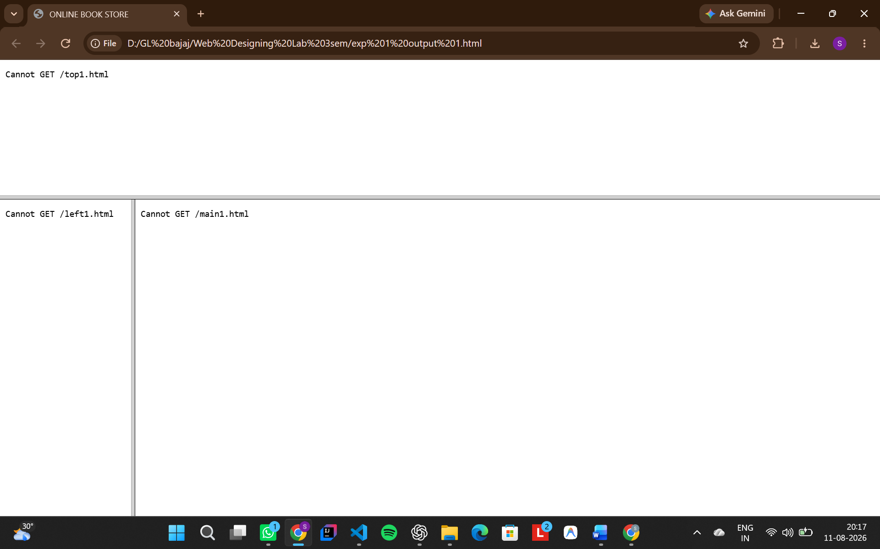

Top.html
<!DOCTYPE html>
<html>

<body bgcolor="#FFB6A6" width="100%">
<table width="100%">
<tr>
<td>
<img src="media/images/logo/logo.png" alt="logo" height="120">
</td>
<td align="center">
<h1>
G.L BAJAJ INSTITUTE OF TECHNOLOGY AND MANAGEMENT
</h1>
<h2>
Online Book Store
</h2>
</td>
</tr>
</table>
<center>
<a href="home.html"
target="Home">HOME</a>&nbsp&nbsp&nbsp&nbsp&nbsp&nbsp&nbsp&nbsp&nbsp&nbsp&nbsp&nbsp&nbsp&nbsp&nbsp&nbsp&nbsp&nbsp&nbsp&nbsp&nbsp&nbsp&nbsp&nbsp&nbsp&nbsp&nbsp&nbsp
<a href="login.html"
target="Login">LOGIN</a>&nbsp&nbsp&nbsp&nbsp&nbsp&nbsp&nbsp&nbsp&nbsp&nbsp&nbsp&nbsp&nbsp&nbsp&nbsp&nbsp&nbsp&nbsp&nbsp&nbsp&nbsp&nbsp&nbsp&nbsp&nbsp&nbsp&nbsp&nbsp
<a href="register.html"
target="Register">REGISTER</a>&nbsp&nbsp&nbsp&nbsp&nbsp&nbsp&nbsp&nbsp&nbsp&nbsp&nbsp&nbsp&nbsp&nbsp&nbsp&nbsp&nbsp&nbsp&nbsp&nbsp&nbsp&nbsp&nbsp&nbsp&nbsp&nbsp&nbsp&nbsp
<a href="catalogue.html" target="Catalogue">CATALOGUE</a>
</center>
</body>

</html>

Output :-

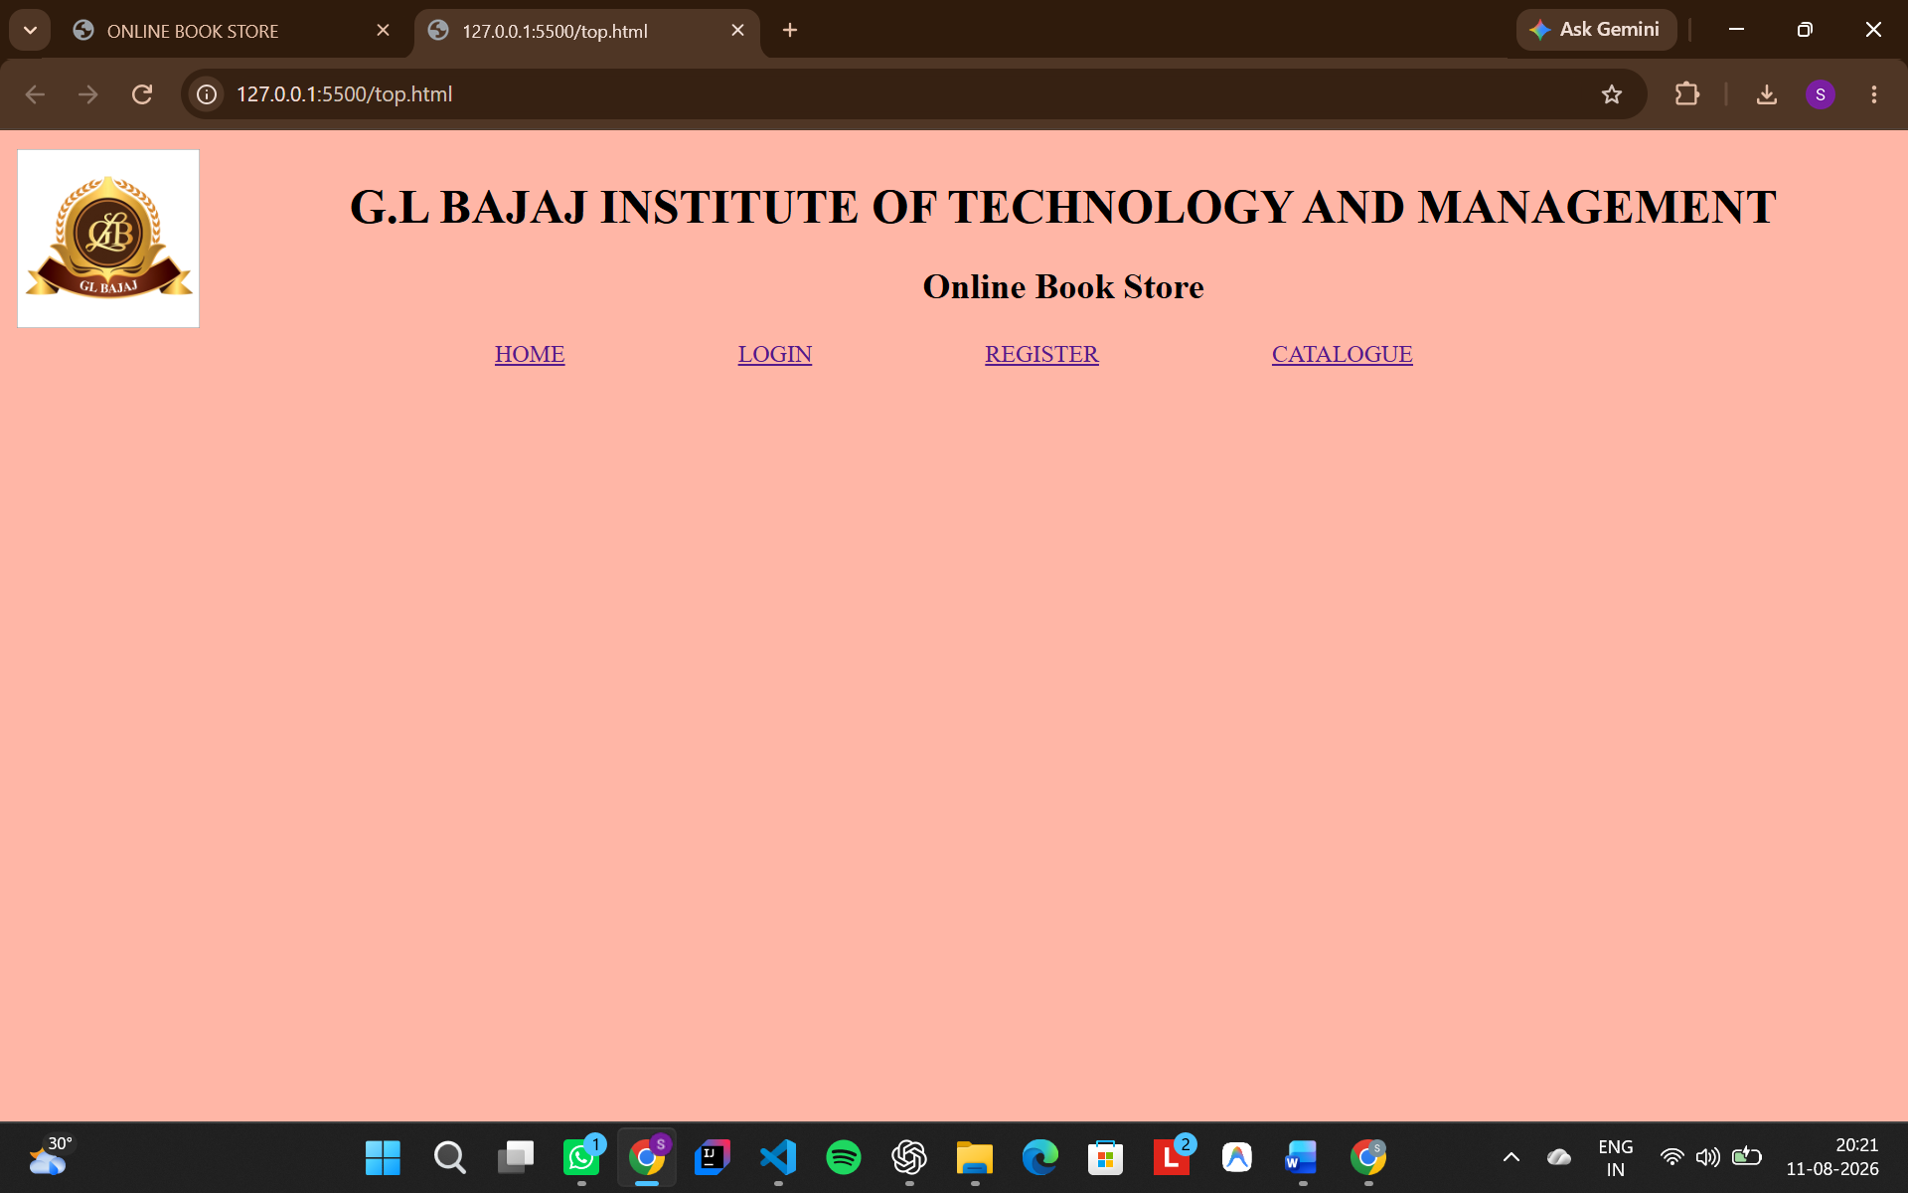

Left.html
<html>
<body bgcolor="#FFEBD3">
<center>
<br><br><br><br>
<h2>
<a href="cse.html" target="home">CSE</a><br><br><br>
<a href="ece.html" target="home">ECE</a><br><br><br>
<a href="eee.html" target="home">EEE</a><br><br><br>
<a href="mech.html"target="home">MECH</a>
</h2>
</center>
</body>
</html>

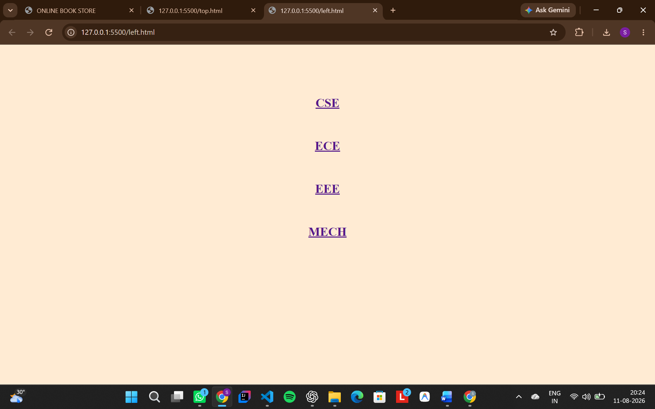

Home.html
<html>

<body bgcolor="#9BCEC1">
<table width="100%">
<tr>
<td align="center" width="70%">
<font size="8" color="#white">Welcome to the Online Book Store of G. L. Bajaj!!!</font><br><br>
<font size="5" color="#white"> Here you will find a wide range of engineering e-books covering
Computer Science, Electronics, Electrical, and Mechanical branches.
Our goal is to provide students with easy access to best study material and reference books
acrossr the India.</font>
</td>
</tr>
</table>
</body>

</html>
Output :-
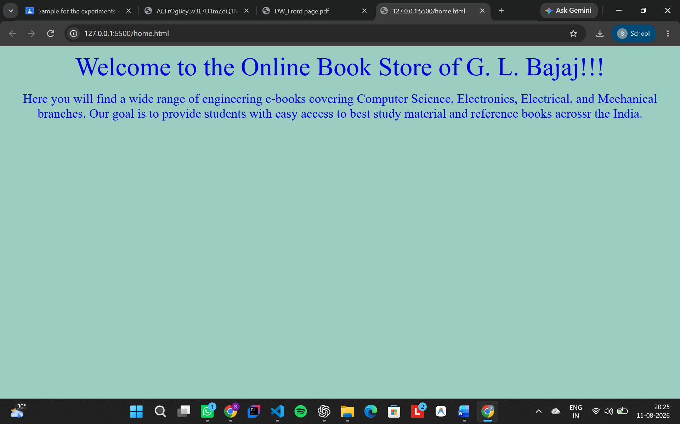

mech.html
<html>

<body bgcolor="#D5D8DB">
<table width="100%" border="5px" bgcolor="#9BCEC1">
<tr>
<td align="left" width="40%">
<img src="media/images/MECHBooks/MECHBook1.jpg" alt="ece book" height="200" width="150">
</td>
<td align="center" width="60%">
<p>
<font size="6" color="#8140DC">Book Name: </font>
<font size="5" color="#8140A7">Power System Engineering (3rd Ed.)</font>
</p>
<p>
<font size="6" color="#8140DC">Author Name: </font>
<font size="5" color="#8140A7">Manish Kumar Goyal, Md Bahauddin</font>
</p>
<p>
<font size="6" color="#8140DC">Price: </font>
<font size="5" color="#8140A7">₹417</font>
</p>
</td>
</tr>
<tr>
<td align="left" width="40%">
<img src="media/images/MECHBooks/MECHBook2.jpg" alt="ece book" height="200" width="150">
</td>
<td align="center" width="60%">
<p>
<font size="6" color="#8140DC">Book Name: </font>
<font size="5" color="#8140A7">Thermal Engineering</font>
</p>
<p>
<font size="6" color="#8140DC">Author Name: </font>
<font size="5" color="#8140A7">Techsar Editorial Board</font>
</p>
<p>
<font size="6" color="#8140DC">Price: </font>
<font size="5" color="#8140A7">₹760</font>
</p>
</td>
</tr>
<tr>
<td align="left" width="40%">
<img src="media/images/MECHBooks/MECHBook3.jpg" alt="ece book" height="200" width="150">
</td>
<td align="center" width="60%">
<p>
<font size="6" color="#8140DC">Book Name: </font>
<font size="5" color="#8140A7">Theory of Machines</font>
</p>
<p>
<font size="6" color="#8140DC">Author Name: </font>
<font size="5" color="#8140A7">R.S. Khurmi, J.K. Gupta</font>
</p>
<p>
<font size="6" color="#8140DC">Price: </font>
<font size="5" color="#8140A7">₹799</font>
</p>
</td>
</tr>
<tr>
<td align="left" width="40%">
<img src="media/images/MECHBooks/MECHBook4.webp" alt="ece book" height="200" width="150">
</td>
<td align="center" width="60%">
<p>
<font size="6" color="#8140DC">Book Name: </font>
<font size="5" color="#8140A7">A Textbook of Strength of Materials</font>
</p>
<p>
<font size="6" color="#8140DC">Author Name: </font>
<font size="5" color="#8140A7">Dr R.K. Bansal</font>
</p>
<p>
<font size="6" color="#8140DC">Price: </font>
<font size="5" color="#8140A7">₹525</font>
</p>
</td>
</tr>

<tr>
<td align="left" width="40%">
<img src="media/images/MECHBooks/MECHBook5.jpg" alt="ece book" height="200" width="150">
</td>
<td align="center" width="60%">
<p>
<font size="6" color="#8140DC">Book Name: </font>
<font size="5" color="#8140A7">A Textbook of Fluid Mechanics and Hydraulic Machines</font>
</p>
<p>
<font size="6" color="#8140DC">Author Name: </font>
<font size="5" color="#8140A7">Dr R.K. Bansal</font>
</p>
<p>
<font size="6" color="#8140DC">Price: </font>
<font size="5" color="#8140A7">₹752</font>
</p>
</td>
</tr>
</table>
</body>

</html>
Output :-
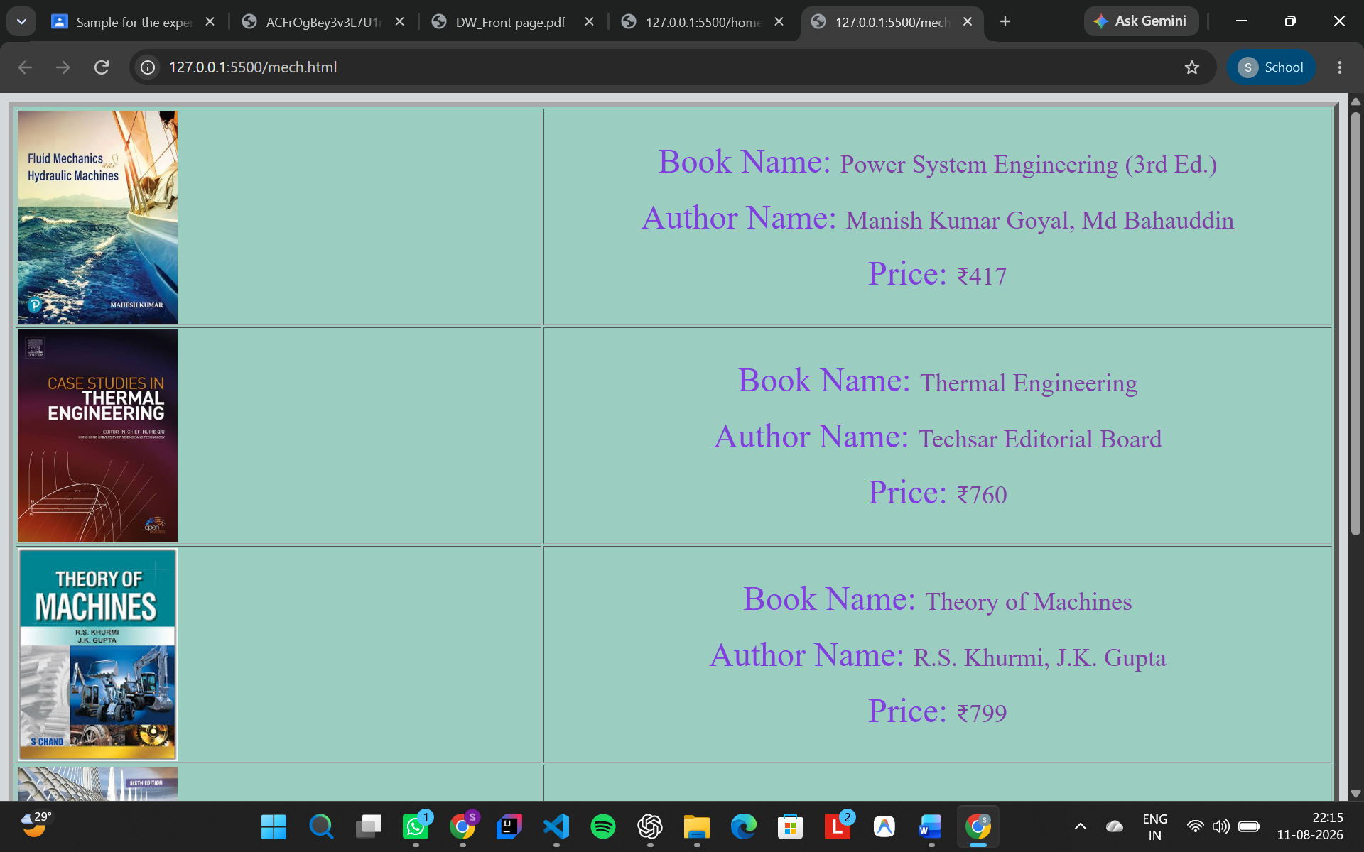
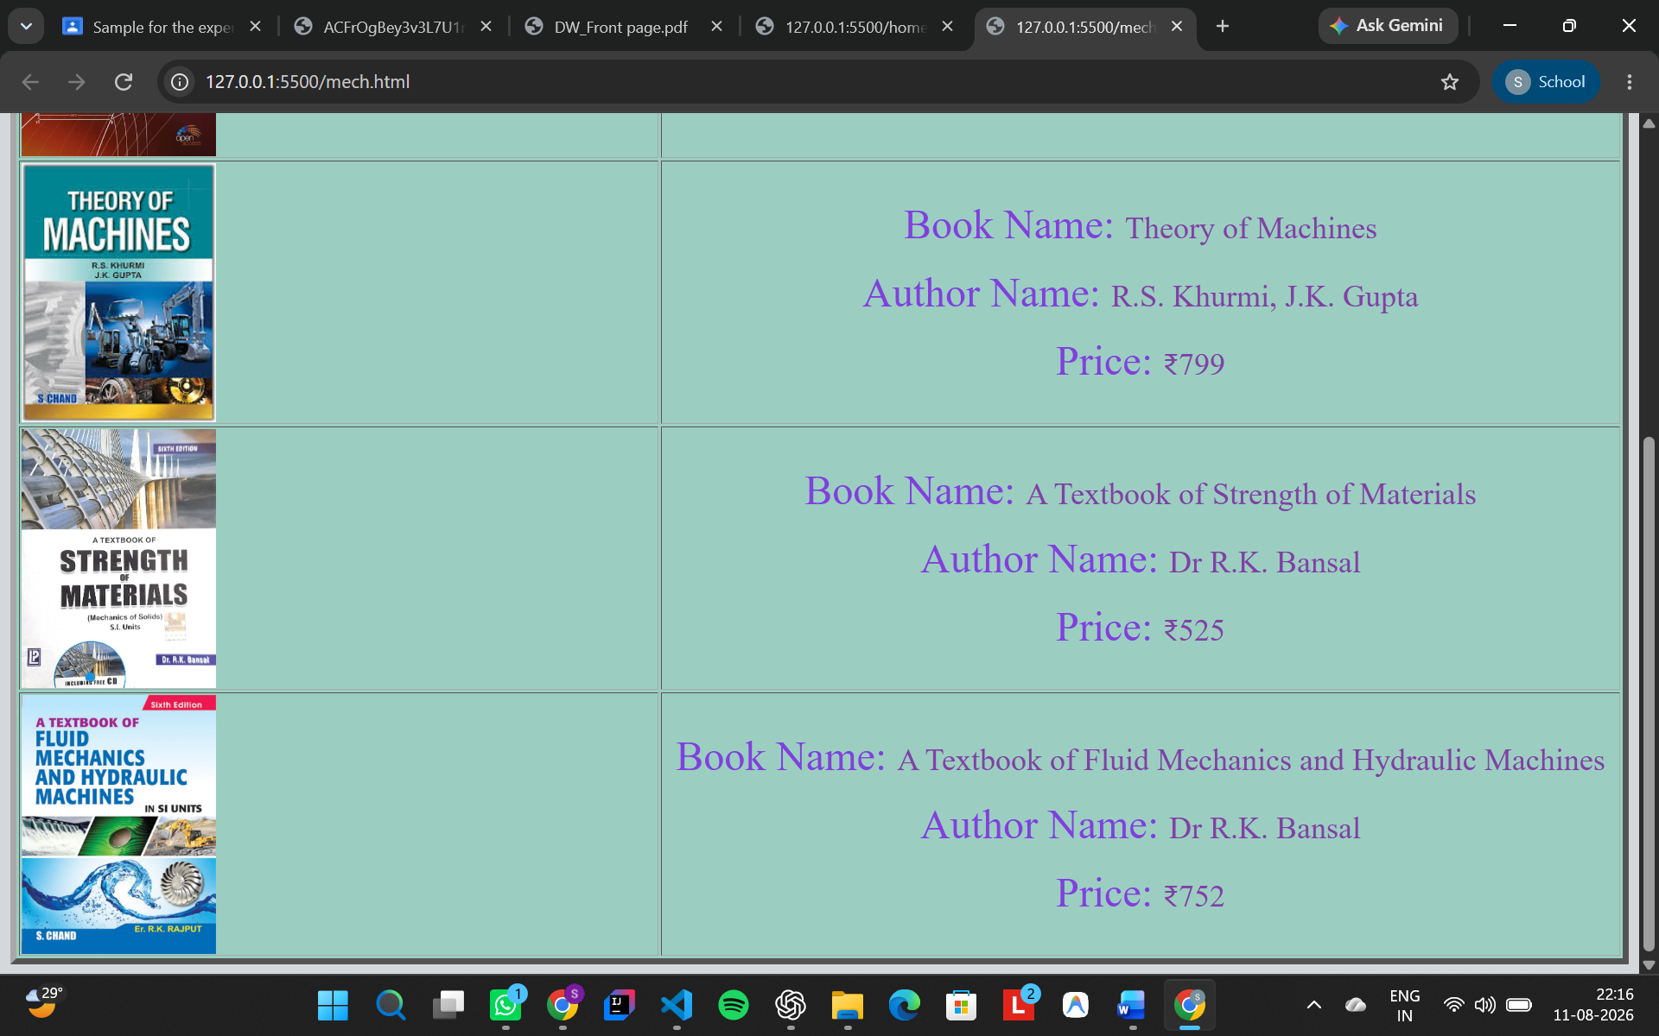

Cse.html
<html>

<body bgcolor="#D5D8DB">
<table width="100%" border="5px" bgcolor="#9BCEC1">
<tr>
<td align="left" width="40%">
<img src="media/images/CSEBooks/CSEBook1.jpg" alt="cse book" height="200" width="150">
</td>
<td align="center" width="60%">
<p>
<font size="6" color="#8140DC">Book Name: </font>
<font size="5" color="#8140A7">Introduction to Algorithms</font>
</p>
<p>
<font size="6" color="#8140DC">Author Name: </font>
<font size="5" color="#8140A7">Cormen, Leiserson, Rivest, and Stein</font>
</p>
<p>
<font size="6" color="#8140DC">Price: </font>
<font size="5" color="#8140A7">₹1999</font>
</p>
</td>
</tr>
<tr>
<td align="left" width="40%">
<img src="media/images/CSEBooks/CSEBook2.webp" alt="cse book" height="200" width="150">
</td>
<td align="center" width="60%">
<p>
<font size="6" color="#8140DC">Book Name: Compilers: </font>
<font size="5" color="#8140DC">Principles, Techniques, and Tools</font>
</p>
<p>
<font size="6" color="#8140DC">Author Name: </font>
<font size="5" color="#8140A7">Aho, Lam, Sethi, Ullman [0.7]</font>
</p>
<p>
<font size="6" color="#8140DC">Price: </font>
<font size="5" color="#8140A7">₹324</font>
</p>
</td>
</tr>
<tr>
<td align="left" width="40%">
<img src="media/images/CSEBooks/CSEBook3.jpg" alt="cse book" height="200" width="150">
</td>
<td align="center" width="60%">
<p>
<font size="6" color="#8140DC">Book Name: Clean Code: </font>
<font size="5" color="#8140A7">A Handbook of Agile Software Craftsmanship</font>
</p>
<p>
<font size="6" color="#8140DC">Author Name: </font>
<font size="5" color="#8140A7">Robert C. Martin</font>
</p>
<p>
<font size="6" color="#8140DC">Price: </font>
<font size="5" color="#8140A7">₹708</font>
</p>
</td>
</tr>
<tr>
<td align="left" width="40%">
<img src="media/images/CSEBooks/CSEBook4.jpg" alt="cse book" height="200" width="150">
</td>
<td align="center" width="60%">
<p>
<font size="6" color="#8140DC">Book Name: Code: </font>
<font size="5" color="#8140A7">The Hidden Language of Computer Hardware and Software (2nd Ed.) </font>
</p>
<p>
<font size="6" color="#8140DC">Author Name: </font>
<font size="5" color="#8140A7">Charles Petzold</font>
</p>
<p>
<font size="6" color="#8140DC">Price: </font>
<font size="5" color="#8140A7">₹2975</font>
</p>
</td>
</tr>

<tr>
<td align="left" width="40%">
<img src="media/images/CSEBooks/CSEBook5.jpg" alt="cse book" height="200" width="150">
</td>
<td align="center" width="60%">
<p>
<font size="6" color="#8140DC">Book Name: </font>
<font size="5" color="#8140A7">The Art of Computer Programming (Vol 3)</font>
</p>
<p>
<font size="6" color="#8140DC">Author Name: </font>
<font size="5" color="#8140A7">Donald E. Knuth</font>
</p>
<p>
<font size="6" color="#8140DC">Price: </font>
<font size="5" color="#8140A7">₹5576</font>
</p>
</td>
</tr>
</table>
</body>

</html>
Output :-
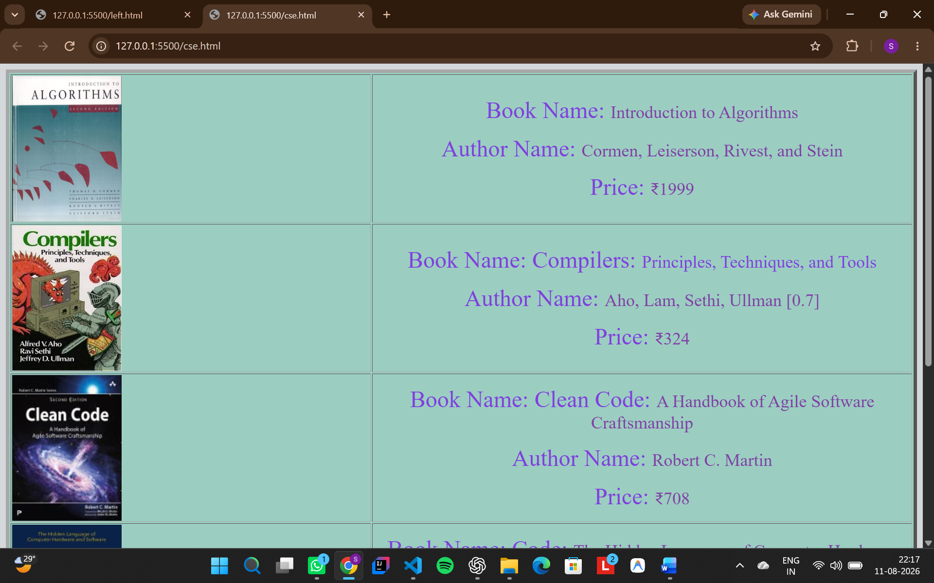
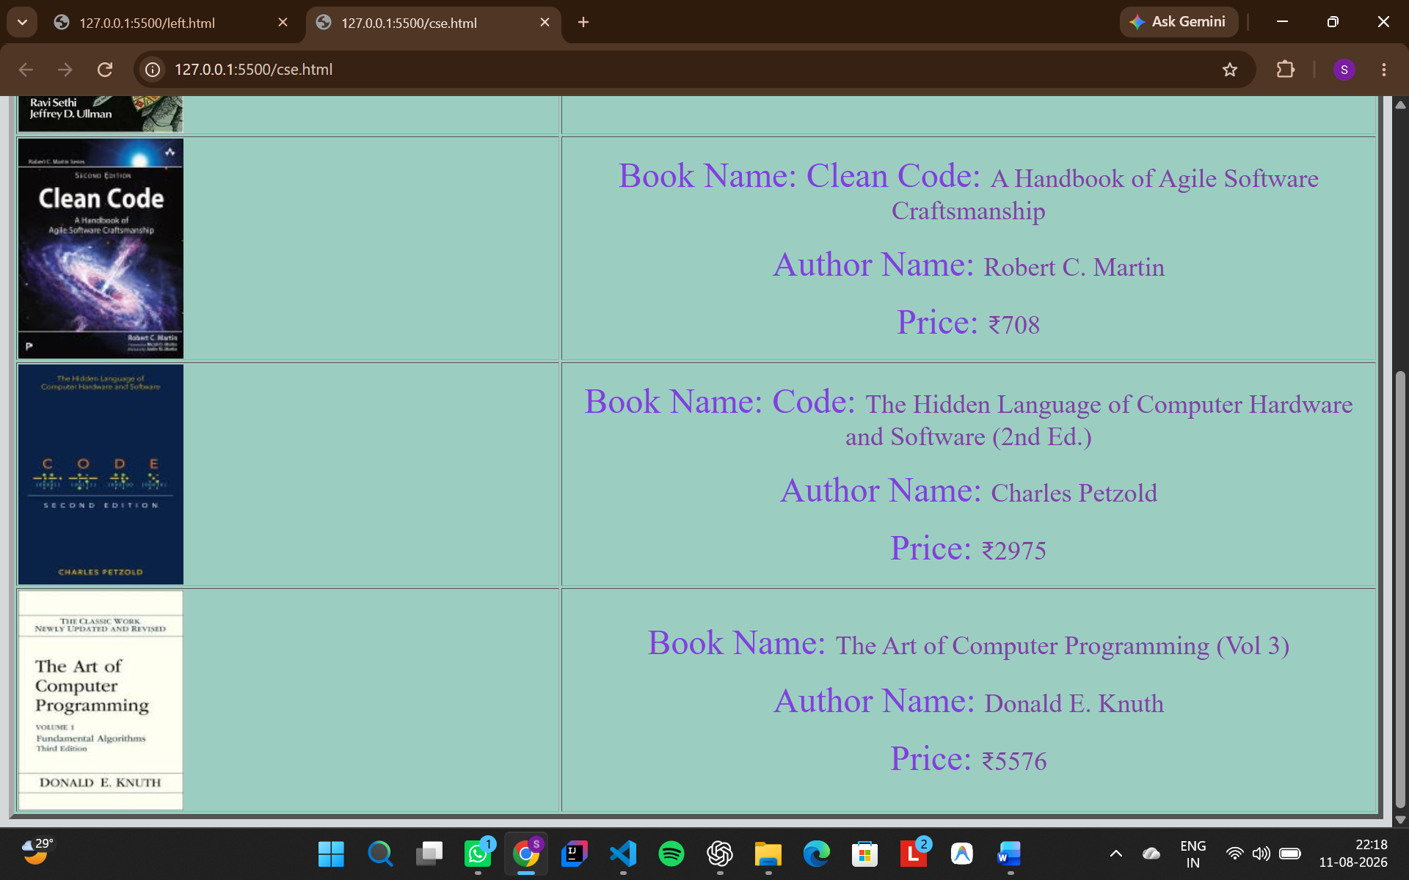

Ece.html
<html>

<body bgcolor="#D5D8DB">
<table width="100%" border="5px" bgcolor="#9BCEC1">
<tr>
<td align="left" width="40%">
<img src="media/images/ECEBooks/ECEBook1.webp" alt="ece book" height="200" width="150">
</td>
<td align="center" width="60%">
<p>
<font size="6" color="#8140DC">Book Name: </font>
<font size="5" color="#8140A7">Microelectronic Circuits: Theory and Applications</font>
</p>
<p>
<font size="6" color="#8140DC">Author Name: </font>
<font size="5" color="#8140A7">Adel S. Sedra, Kenneth C. Smith</font>
</p>
<p>
<font size="6" color="#8140DC">Price: </font>
<font size="5" color="#8140A7">₹652</font>
</p>
</td>
</tr>
<tr>
<td align="left" width="40%">
<img src="media/images/ECEBooks/ECEBook2.jpg" alt="ece book" height="200" width="150">
</td>
<td align="center" width="60%">
<p>
<font size="6" color="#8140DC">Book Name: </font>
<font size="5" color="#8140A7">Compilers: Principles of Electromagnetics (6th Ed.)</font>
</p>
<p>
<font size="6" color="#8140DC">Author Name: </font>
<font size="5" color="#8140A7">Matthew N.O. Sadiku</font>
</p>
<p>
<font size="6" color="#8140DC">Price: </font>
<font size="5" color="#8140A7">₹1250</font>
</p>
</td>
</tr>
<tr>
<td align="left" width="40%">
<img src="media/images/ECEBooks/ECEBook3.webp" alt="ece book" height="200" width="150">
</td>
<td align="center" width="60%">
<p>
<font size="6" color="#8140DC">Book Name: </font>
<font size="5" color="#8140A7">Signals and Systems (2nd Ed.)</font>
</p>
<p>
<font size="6" color="#8140DC">Author Name: </font>
<font size="5" color="#8140A7">Alan V. Oppenheim, Alan S. Willsky</font>
</p>
<p>
<font size="6" color="#8140DC">Price: </font>
<font size="5" color="#8140A7">₹620</font>
</p>
</td>
</tr>
<tr>
<td align="left" width="40%">
<img src="media/images/ECEBooks/ECEBook4.webp" alt="ece book" height="200" width="150">
</td>
<td align="center" width="60%">
<p>
<font size="6" color="#8140DC">Book Name: </font>
<font size="5" color="#8140A7">Code: Digital Design (6th Ed.)</font>
</p>
<p>
<font size="6" color="#8140DC">Author Name: </font>
<font size="5" color="#8140A7">M. Morris Mano, Michael D. Ciletti</font>
</p>
<p>
<font size="6" color="#8140DC">Price: </font>
<font size="5" color="#8140A7">₹475</font>
</p>
</td>
</tr>

<tr>
<td align="left" width="40%">
<img src="media/images/ECEBooks/ECEBook5.webp" alt="ece book" height="200" width="150">
</td>
<td align="center" width="60%">
<p>
<font size="6" color="#8140DC">Book Name: </font>
<font size="5" color="#8140A7">Modern Digital and Analog Communication Systems</font>
</p>
<p>
<font size="6" color="#8140DC">Author Name: </font>
<font size="5" color="#8140A7">B.P. Lathi, Zhi Ding</font>
</p>
<p>
<font size="6" color="#8140DC">Price: </font>
<font size="5" color="#8140A7">₹506</font>
</p>
</td>
</tr>
</table>
</body>

</html>
Output :-
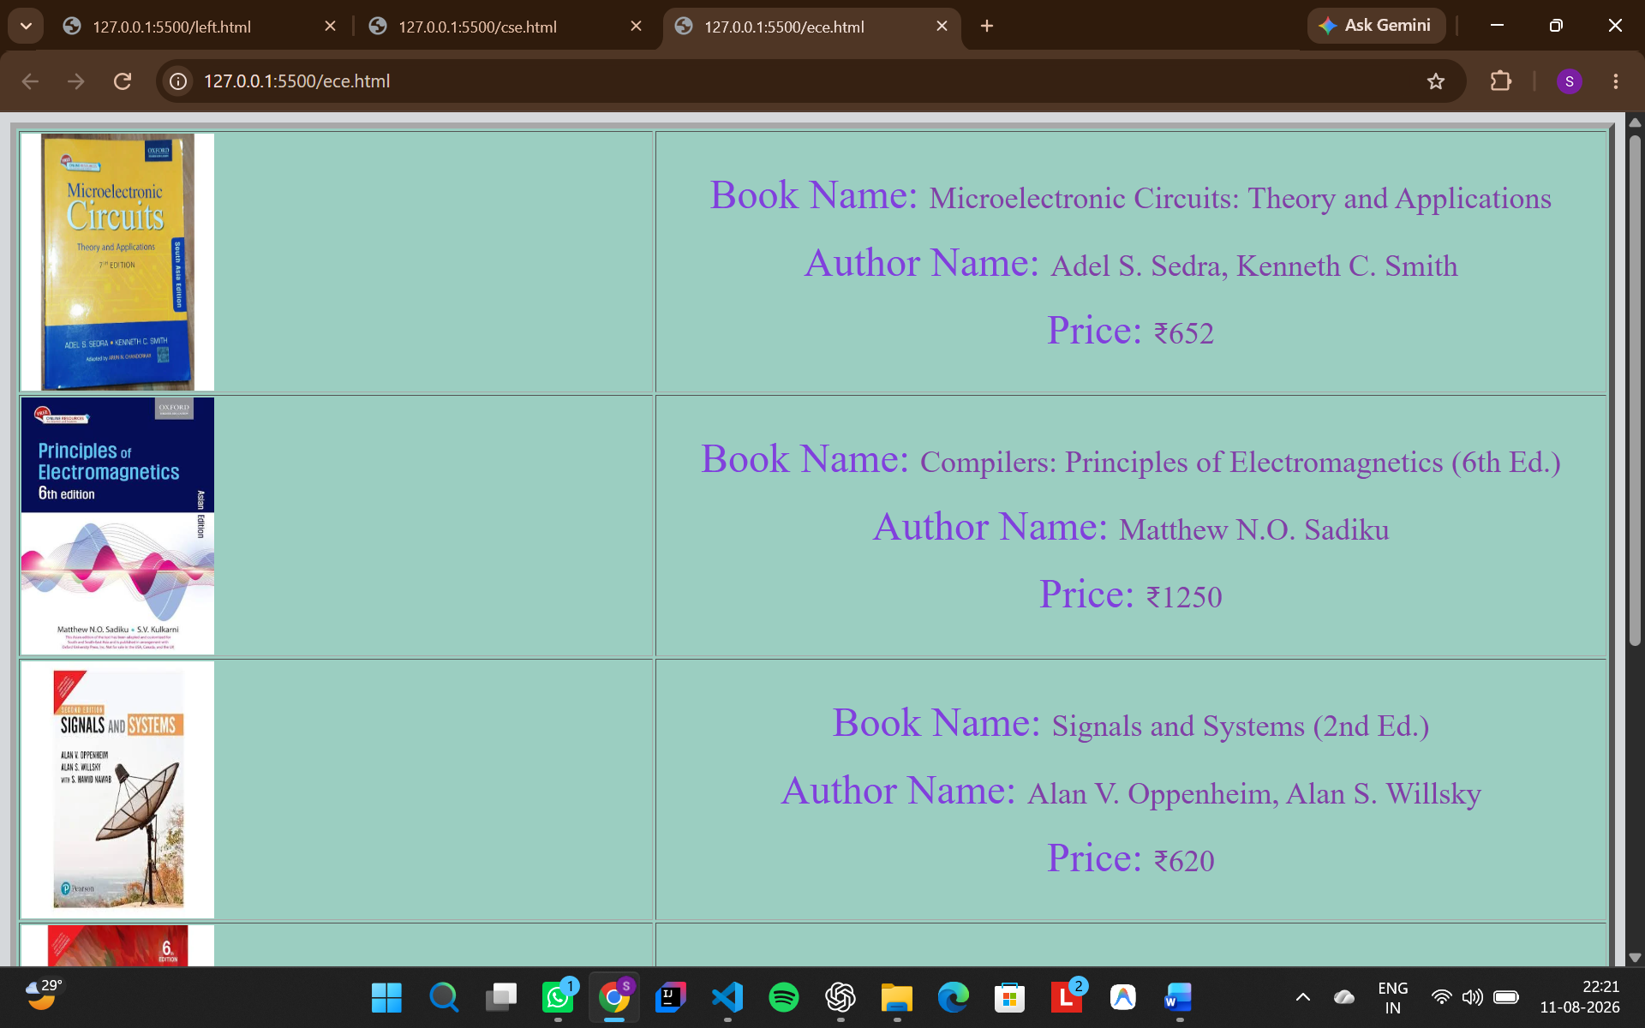
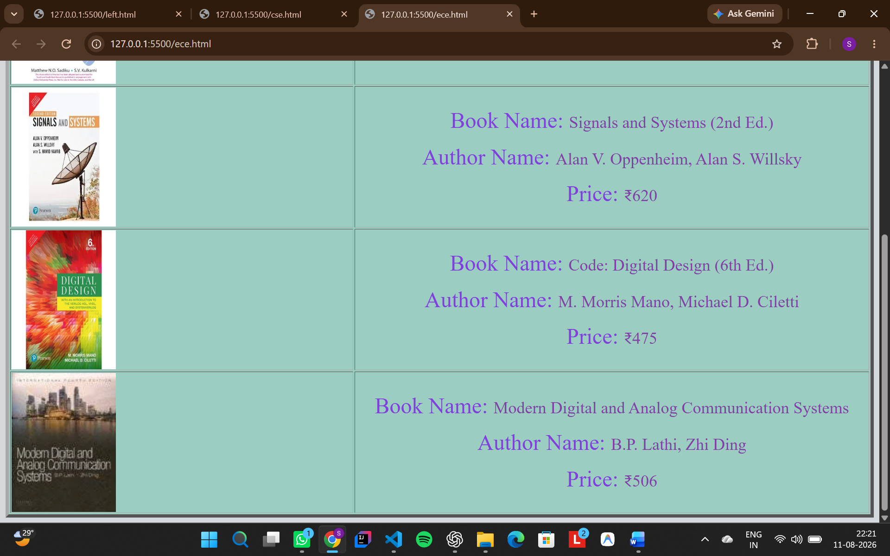

Eee.html
<html>

<body bgcolor="#D5D8DB">
<table width="100%" border="5px" bgcolor="#9BCEC1">
<tr>
<td align="left" width="40%">
<img src="media/images/EEEBooks/EEEBook1.webp" alt="ece book" height="200" width="150">
</td>
<td align="center" width="60%">
<p>
<font size="6" color="#8140DC">Book Name: </font>
<font size="5" color="#8140A7">Electrical Machinery (7th Ed.)</font>
</p>
<p>
<font size="6" color="#8140DC">Author Name: </font>
<font size="5" color="#8140A7">Dr P.S. Bimbhra</font>
</p>
<p>
<font size="6" color="#8140DC">Price: </font>
<font size="5" color="#8140A7">₹750</font>
</p>
</td>
</tr>
<tr>
<td align="left" width="40%">
<img src="media/images/EEEBooks/EEEBook2.jpg" alt="ece book" height="200" width="150">
</td>
<td align="center" width="60%">
<p>
<font size="6" color="#8140DC">Book Name: </font>
<font size="5" color="#8140A7">Power System Engineering (3rd Ed.)</font>
</p>
<p>
<font size="6" color="#8140DC">Author Name: </font>
<font size="5" color="#8140A7">D.P. Kothari, I.J. Nagrath</font>
</p>
<p>
<font size="6" color="#8140DC">Price: </font>
<font size="5" color="#8140A7">₹815</font>
</p>
</td>
</tr>
<tr>
<td align="left" width="40%">
<img src="media/images/EEEBooks/EEEBook3.jpg" alt="ece book" height="200" width="150">
</td>
<td align="center" width="60%">
<p>
<font size="6" color="#8140DC">Book Name: </font>
<font size="5" color="#8140A7">Automatic Control System</font>
</p>
<p>
<font size="6" color="#8140DC">Author Name: </font>
<font size="5" color="#8140A7">Benjamin C. Kuo, Farid Golnaraghi</font>
</p>
<p>
<font size="6" color="#8140DC">Price: </font>
<font size="5" color="#8140A7">₹357</font>
</p>
</td>
</tr>
<tr>
<td align="left" width="40%">
<img src="media/images/EEEBooks/EEEBook4.webp" alt="ece book" height="200" width="150">
</td>
<td align="center" width="60%">
<p>
<font size="6" color="#8140DC">Book Name: </font>
<font size="5" color="#8140A7">Power Electronics: Circuits, Devices, and Applications</font>
</p>
<p>
<font size="6" color="#8140DC">Author Name: </font>
<font size="5" color="#8140A7">Muhammad H. Rashid</font>
</p>
<p>
<font size="6" color="#8140DC">Price: </font>
<font size="5" color="#8140A7">₹700</font>
</p>
</td>
</tr>

<tr>
<td align="left" width="40%">
<img src="media/images/EEEBooks/EEEBook5.jpg" alt="ece book" height="200" width="150">
</td>
<td align="center" width="60%">
<p>
<font size="6" color="#8140DC">Book Name: </font>
<font size="5" color="#8140A7">Control Systems Engineering</font>
</p>
<p>
<font size="6" color="#8140DC">Author Name: </font>
<font size="5" color="#8140A7">Norman S. Nise</font>
</p>
<p>
<font size="6" color="#8140DC">Price: </font>
<font size="5" color="#8140A7">₹521</font>
</p>
</td>
</tr>
</table>
</body>

</html>

Output :-
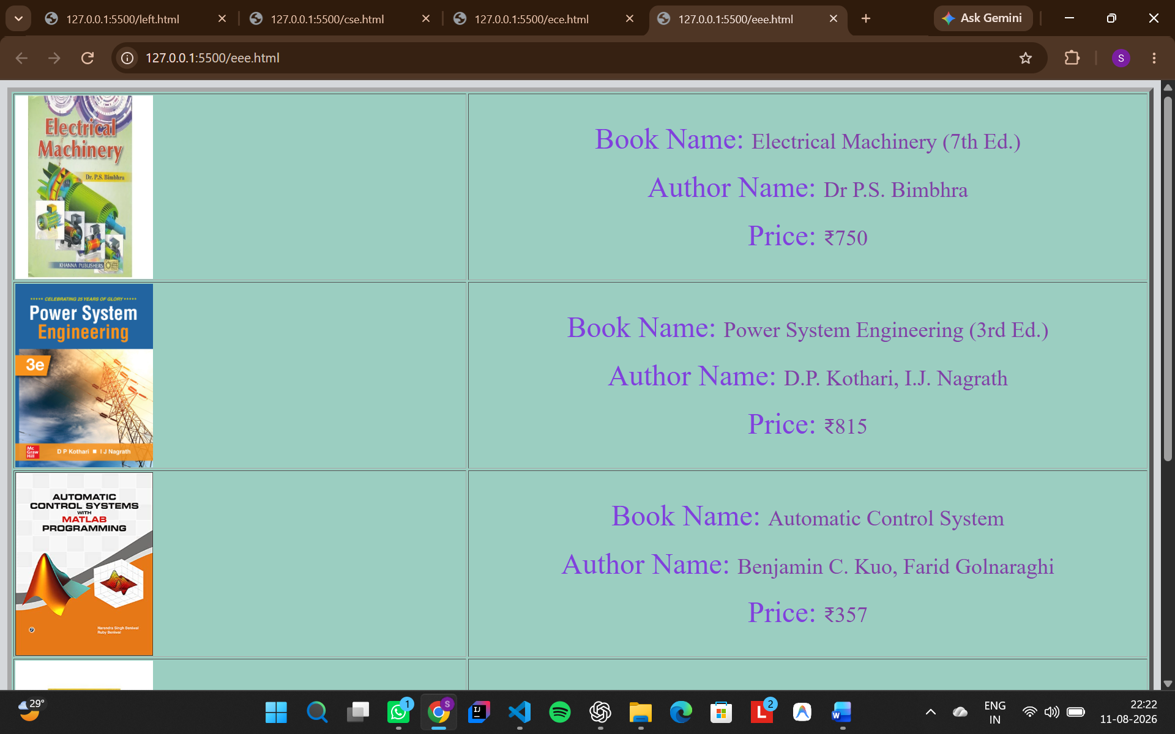
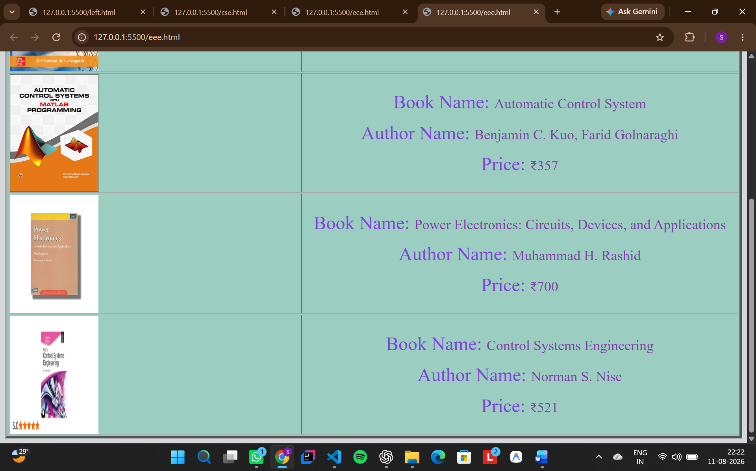

Overall Output :-
